**DATABASE ASSIGNMENT**

**String Matching Algorithm-Group 53**

PALLIYAGURUGE H.N. -17001201 pghasandi@gmail.com

PANAGODA N.N. – 17001226 nvnnvnpersonal@gmail.com

PAVITHRANI D.V.M. – 17001242 maheemapavithrani@gmail.com

**Read me file**

Question (1)

Why did we use Naïve Algorithm(Brute-Force Algorithm)

In this question we have used Naïve Algorithm. Among the various types of string matching algorithms Brute Force Algorithm or Naïve algorithm is the simplest algorithm for string matching. Simply what is happening in that algorithm is that it tries to match the first character of the pattern with the first character in the text and if succeed, try to match the second character and so on. If an unmatching character found it sifts the string over one character and try again.

As we use a wildcard (_ ) here naïve algorithm is the most suitable algorithm.

Code Description

In our program there is the main c++ file named Q1.cpp. There we have used library fstream to read and write files. When the code run two input files should be given. They are as textfile and patternfile. In text file we should give the file with text which want to search for the pattern. Pattern file should include the pattern

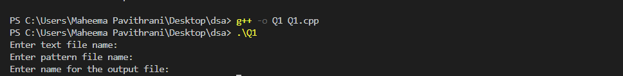

Search_pattern() – Two parameters named parag and pat are passed into the function.

lt and lp are two variables which gives the lengh of text and pattern respectively. If lp and lt are 0 then there is no string to search so it prints as “There is no string or pattern”.

When the function call name of output file must be given by the user. Then the position prints in that file.

Test cases

Text.txt is the text file and there are two pattern files we created as pattern1 and pattern2.

Text.txt file- “thisisatestthistesthastoassignment”

Pattern1.txt- only one wildcard is used. (“h_s”)

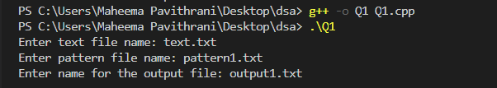

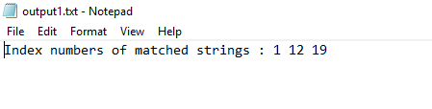

Patern2.txt- only two wildcards used.(“t__t”)

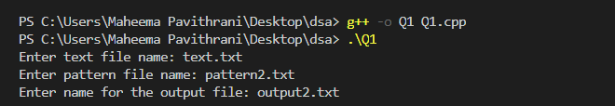

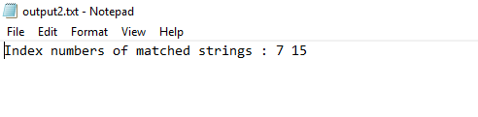

Pattern3.txt - no any matching character (“apple”)

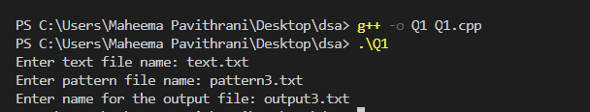

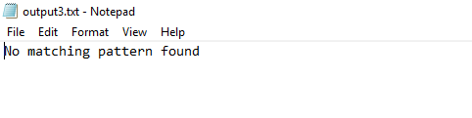

Output1 is output file we created.

Limitations

* Pattern can possess more than one wild card.
* String and pattern must give as text files
* Output also given as a text file.